Contents
Description 1
Access 1
Update NYP Clients 2
Add/Remove NYP Clients 3
Create New Holiday Schedule Using Templates 4
Create a New Holiday Schedule using a current Holiday Schedule 5
Create New Google Form/ Response Sheet 6
Set Scripts To Send Emails 7
Send Email Report Open and Closed Holidays 10
Send REPS Holiday Schedule Url’s 10
Google Sheets/Forms Templates 11
Completed 11

Create Holiday Schedules

Description
The intent of the holiday closure module is to allow Client Services to keep track of which clients are open & closed on holidays or snow days. Previously, they were manually tracking everything through email and local spreadsheets. The possible future need for remote access to the data by carriers in the field prevented us from developing anything with the existing system. A spreadsheet and data entry form in Google Docs was determined to be the simplest/most cost effective solution. The Google Sheets templates are under the folder /HOLIDAY CLOSURES TEMPLATE. The main template is /HOLIDAY CLOSURES TEMPLATE/Holiday_Closures_Template and the main template for other closures is /HOLIDAY CLOSURES TEMPLATE /Snow_Day_Closure_Data_Entry_Template.

Access
Log into Google Sheets / Google Docs
  - Nyp.lab.outreach@gmail.com
  - NYPeD0cs525

Update NYP Clients
This will update the current NYP Clients MASTER Google Sheet. Click on the link Add/Remove to see how to add or remove NYP Clients.
- The Google Sheet that holds the NYP Clients that will be updated is under HOLIDAY CLOSURES TEMPLATE/Update NYP Client Information (Responses).
- The Google Form that has the fields that will be updated is under HOLIDAY CLOSURES TEMPLATE\ Update NYP Client Information.
- When you update the MASTER Google sheet, you should update the MASTER template. Right know the master template is MY Drive/ HOLIDAY CLOSURES TEMPLATE/ Holiday_Closures_Template.
- To update a NYP Client open the Google Sheet MY Drive/ HOLIDAY CLOSURES TEMPLATE/ Holiday_Closures_Template.
- Select the tab MASTER.
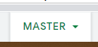
- Find the NYP Client that needs to be update and click on the link UPDATE DETAILS.
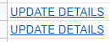
- This will open the Google Form:
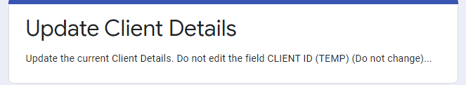
Do not change the data in the field CLIENT ID(TEMP) as this field is used to find what NYP Client needs updated.
- After the NYP Client has been update click the submit button.
- To see the updated NYP Client information Click on the tab UPDATERMASTER.
- To update the Google Master Sheet click on the tab and click the button Update Master Sheet. To update other Google Sheets open the Google Sheet that need updated do the same thing.
- Once all the Google Sheets have been updated or before the next update delete rows 2-N in HOLIDAY CLOSURES TEMPLATE/Update NYP Client Information (Responses).

Add/Remove NYP Clients
- In the google drive folder HOLIDAY CLOSURES TEMPLATE opened the google sheet Holiday_Closures_Template.
- Select the tab MASTER.
- Add Client:
- Go to the last client in the Google Sheet and highlight that row.
- Right mouse click and copy
- Select the row below and right mouse click and select past
- If you have more then one Holiday Closures Template they you want to run the script that’s updates the MASTER Sheet. To do this in the MASTER Sheet add the text new client in the Group column update link. After you submit the Google Form update the MASTER Sheet.
- The new row will be the new client so add the information for the new client. The columns CLIENT ID (TEMP) and CLIENT ID will be populated from the information from the columns GROUP, ADDRESS, DEPARTMENT, AND DR NAME.
- Once the new client is added the PUBLIC Google Sheet will be updated with the new client.
- If you want to run the script that’s update the client in the Group column just add new client as the name then and click on the update link.

- Remove client:
- Go the client that needs to be removed and select the row.
- If you want to put the client in the Google Sheet Retried right mouse click and select Copy. Select the Retried Tab and go to the last row and right mouse click and select paste.
- On the MASTER tab to delete the client right mouse click on the highlighted row and select Delete Row.
- You can delete more the one row at a time by highlighting each row you want to delete then do steps b-c.
To delete separate rows select the rows to be deleted and mouse click select Delete Selected Rows.
To delete columns in a row select the first row to be deleted and then the last row to be deleted. Right mouse click and select Delete rows First Row-Last Row e.g.(Delete rows 301 – 305).
- The public Google Sheet will be updated with the changes.
- Select the INFO tab to make changes to for the REPS.

Create New Holiday Schedule Using Templates
If you need to make changes to the master follow the steps for Update NYP Clients.
- In the google drive folder HOLIDAY CLOSURES TEMPLATE opened the google sheet Holiday_Closures_Template for a Holiday Closures or Snow Day Closures Template for a snow day.
- Select File> Make Copy
  - Name: Select an appropriate HOLIDAY NAME
  - Folder: Select folder “HOLIDAYS”
  - Do not check any of the options “Share…” or “Copy…”
  - Press “OK”

- The spreadsheet will make copy of the desired spreadsheet.
- After the file has been copied select the tabs Responses and click on allow access, UpDateResponsed and click on allow access.
- Select the INFO tab to change the HOLIDAY DATE.
- In the google drive folder HOLIDAY CLOSURES TEMPLATE use the Google Sheet Holiday_Closures_Template for holiday closures:
  - Select Holiday Closure Data Entry right mouse click Open With Google Forms.
  - Under Holiday Closure Data Entry change the text to be displayed on the form.
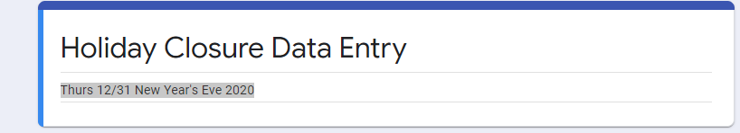
  - Changed to the new holiday.
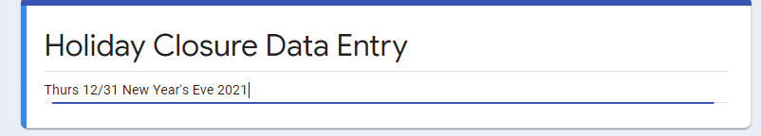
  - To clear out the response from the previous holiday:
Select Holiday Closure Data Entry Responses Template and double click. Select all the rows starting at the second row in the Google Sheet then right mouse click and Select Delete rows 2-Last Selected row.
- In the google drive folder HOLIDAY CLOSURES TEMPLATE use the Google Sheet Snow Day Closures Template if you cannot use the Holiday_Closures_Template for a snow day.
  - Follow steps 2-5 to create the template.
  - For step 5 want to edit the Google Form Snow_Day_Closure_Data_Entry_Template and Snow_Day_Closure_Data_Entry_Template (Responses).

Create a New Holiday Schedule using a current Holiday Schedule
IF you do not need to save the current holiday schedule or update the master you can just make changes to the title of the old holiday schedule.
- Select an old schedule
- Change the name to the new holiday schedule
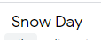
- If it was an Holiday_Closures_Template follow the steps to update the Google Form the sheet Google responses .
- If it was an Google Sheet Snow Day Closures Template follow the steps to update the Google Form the sheet Google responses .

Create New Google Form/ Response Sheet
When you create new Google From you have to link the Google Form to the Google Responses.
- Right mouse click Holiday Closure Data Entry or Snow_Day_Closure_Data_Entry_Template select Make Copy.
- Select Copy of Holiday Closure Data Entry and right mouse click and rename the file to the name you want.
- Right mouse click the Google Form and select Open With Google Form.
- Make note of the FormID in red from the url https://docs.google.com/forms/d/1LW232HuH3pWK5BebtLP6Zz4jaKOP87IqTG2nnjzuGz4/edit
- On the Google Form select the tab Responses.
- On the response form select
On the drop down that is open Select Response Destination

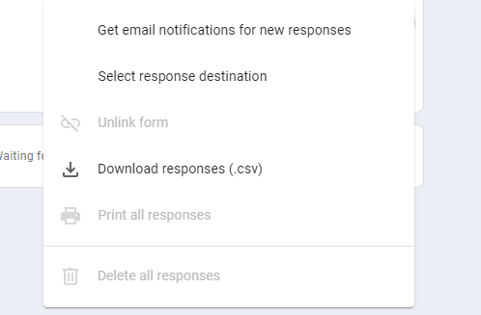
- On the form that is opened select Create a new spreadsheet.
- Once this is created click on this will open the new responses Google Sheet.
- Make not of the Google Sheet ID in red https://docs.google.com/spreadsheets/d/1HNUdjaPms8FbhYVONyLPy2XvMaZk10o_X2BX7maGVg4/edit#gid=593716263.
- Open the Holiday Google Sheet
- Select the MASTER tab then select Column B title SET SCHEDULE to display the new Google Form.
- In the top you will see change the one in red to the FORMID
=ArrayFormula(IF(ROW(A1:A)=1,"SET SCHEDULE", IF(N1:N = "NO", HYPERLINK("https://docs.google.com/forms/d/18NGjRqgqRShk5XBL5XGkoBlq_GEHoz54miLu2tR4kCw/viewform?" & "entry.290043132=" & TEXT(INFO!$B$2,"yyyy-mm-dd") & "&entry.1321700592=" & L1:L & "&entry.238345466=" & H1:H & "&entry.1557769609=" & D1:D & "&entry.992448128=" & K1:K , "SET SCHEDULE"),"")))

- Select the RESPONSES tab then select the column A Time stamp.
- To add the new RESPONSES Google Sheet change the one in red to the Google Sheet ID =query(importrange("1HNUdjaPms8FbhYVONyLPy2XvMaZk10o_X2BX7maGVg4","Form Responses 1!A:N"), "select * where Col2 = '" & INFO!B2 & "' order by Col1 asc", 1)
- Select the OPEN tab and the CLOSED tab and follow step 14.

Set Scripts To Send Emails
- This has to be done each time a copy of a holiday schedule is made. Select the UPDATERMASTER tab and click on the Timestamp column. Select allow access.
- Select SendEmailOpenClosed tab.
- Click on one of the buttons.
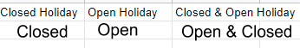
- This will bring up a dialog to let the scripts run.
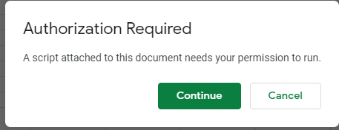
Select Continue
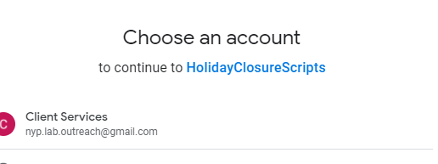
Select Client Services
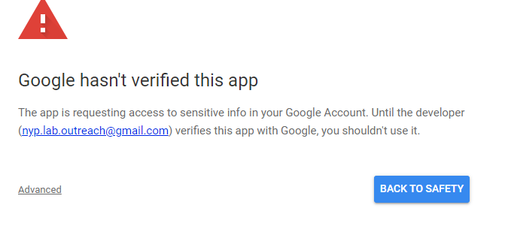
Select Advanced
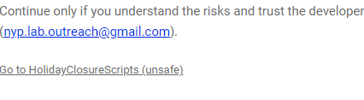
Select Go to HolidayClosureScripts (unsafe)
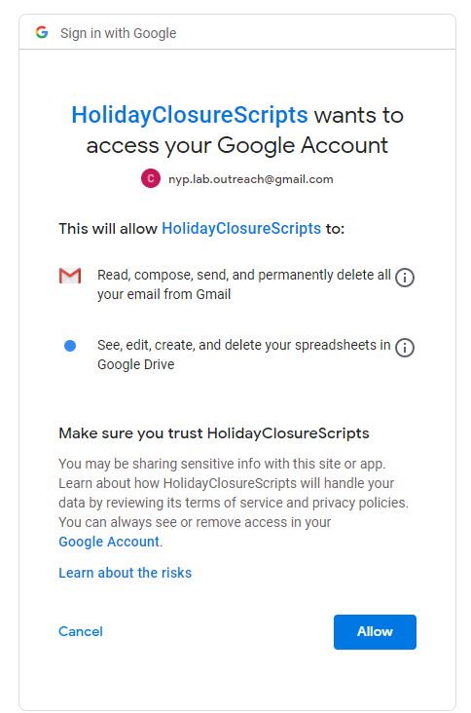
Select Allow as this will allow the scripts to run.

Send Email Report Open and Closed Holidays
- To send the emails and setup who gets the emails select the tab SendEmailOpenClosed.If the EmailTo does not change the update the master template with this information. The emails that are sent are in html format.
- EmailTO column is who will receive the emails. Separate each EmailTO with a ;
- EMailSubject is what will be added to the email subject when the email is sent.
- EmailMessage is not used at this time as the email is in html format. For future development.
- Closed Holiday column button Closed will send an email of all the closed clients for that holiday.
- Open Holiday column button Open will send an email of all the open clients for that holiday.
- Closed & Open Holiday column button Open & Closed will send an email of clients that are open and closed for that holiday.
- To send an email click on the button for the email you want to send.
- If you click on the button, and the Authorization Required dialog comes up go to step Set Scripts To Send Emails.

Send REPS Holiday Schedule Url’s
- This will send an email to the REPS with the url for the current Holiday Schedule. Select the tab INFO and the master templates should be updated with this information.
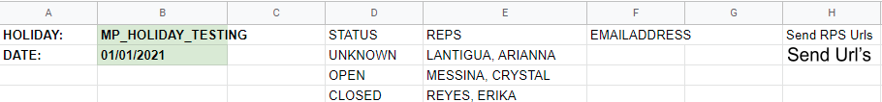
- EMAILADDRESS is the address the email will be sent to. If one of the RESP does not get an email select the master tab and make sure the master CS REP is in the info and the name are the same. e.g.(in the master the name is CSrep and in the info it is CS rep it will not find it. As they have to be exact.).
- To send the email click on the button Send Url’s.
- The email sent will have the information for there Holiday Schdule.
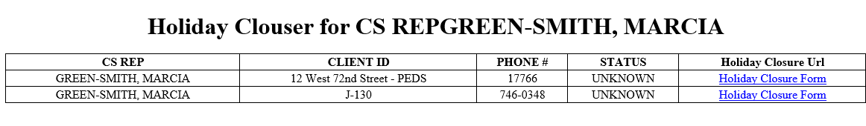
- When the REP selects the link it will bring up the information for their Holiday Schedule.

Google Sheets/Forms Templates
- The Google Sheets Templates are under the folder My Drive/ HOLIDAY CLOSURES TEMPLATE.
- To see what Google Sheet Formals are used click on the column head and it will show what formals are used. The screen is from the MASTER tab column UPDATE DETAILS.
- The MASTER template/Google Sheet is Holiday Closure Data Entry.
- The Google Response Sheet is Holiday Closure Data Entry Responses Template. The response template rows 2 to end should be deleted when you have new Holiday Closures..
- The Google Form is Holiday Closure Data Entry.
- The Google Script that is used is called Code.gs.
- If you remove rows from the MASTER tab and have other templates you will also need to remove these rows from other templates.
- The template to use for other closures is Snow Day Closures Template.
- The Google Form is Snow_Day_Closure_Data_Entry_Template.
- The Google Response Sheet is Snow_Day_Closure_Data_Entry_Template (Responses). The response template rows 2 to end should be deleted when you have new Holiday Closures..
- The Google Script that is used is called Code.gs.

- The update NYP Client is the Google form Update NYP Client Information.
- The Google Response Sheet Update NYP Client Information (Responses). After all the Google Master sheets are updated rows 2-end should be deleted.

Completed
Once this is all completed, you will email Courtney, Dreama, Nelkis, and CC Marc G.
Two links that you will need to share are as follow:
- To hide tabs you don’t want other users to see click on drop down arrow on the tab and select Hide Sheet.
- The new Holiday sheet [Shareable link]
- The Holiday Closure Data Entry – HolidaynameYEAR – Responses sheet [shareable link]
- Send the url’s to the REPS.

